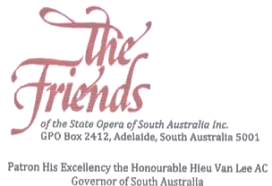

Notice is hereby given that the 44th Annual General Meeting of the Friends of the State Opera of South Australia Inc. will be held in the State Opera Studio, 216 Marion Rd, Netley, 5037
SATURDAY 4TH APRIL 2020 AT 2.30 PM
AGENDA

- Apologies
- To confirm the minutes of the 43rd Annual General Meeting held on Sunday 14th April 2019 at 2.30 pm.
- To receive and consider the report of the President for the year ending 30th November 2019
- To receive and consider the Statement of Accounts for the Society for the year ended 30th November 2019
- To elect Officers of the Society and Members of the Committee
- To appoint an Auditor or Auditors.
- In accordance with the provision of Clause 8.1. c .v in the 2016 Constitution: To deal with any other business requiring consideration by the Association in General Meeting.
- State Opera of South Australia Report.
- Any other business:
  - Future of The Friends
  - The Friends Partnership Agreement with State Opera SA
  - The Friends program 2020
- Guest Artist

BY DIRECTION OF THE COMMITTEE
Yvonne McMurray (Hon. Secretary)

At the conclusion of the formal part of the meeting, you are invited to join the Committee for afternoon tea.

Please notify the Secretary by the 28th March 2020 if you are attending the meeting. Such notification is NOT obligatory - all members have the right to attend the meeting whether or not they have given notice of the intention to do so. Kindly telephone O439 981 517, email friendssaopera@gmail.com or write to The Friends of the State Opera SA Inc. GPO Box 2412 ADELAIDE 5001.

